**Assignment 1:** Introduction to DDL and basic DML Commands

| **cust_id** | **cust_fname** | **cust_lname** | **territory** | **cred_limt** | **mngr_id** | **marital_status** | **income** |
| --- | --- | --- | --- | --- | --- | --- | --- |
|  |  |  | America |  |  |  |  |
|  | Meg | Sen | Italy |  |  |  |  |
|  |  |  | India | 5000 |  | Single |  |

1.Create and insert given data in table customer.

**Query:**

create table customer(

cust_id number,

cust_fname varchar2(10),

cust_lname varchar2(10),

territory varchar2(10),

cred_limit number(10),

mngr_id number(10),

marital_status varchar2(10),

income number(20)

);

insert into customer(cust_id,cust_fname,cust_lname,territory,cred_limit,mngr_id,marital_status,income) values (‘’,'','','America','','','','');

insert into customer(cust_id,cust_fname,cust_lname,territory,cred_limit,mngr_id,marital_status,income) values (‘’,'Meg','Sen','Italy','','','','');

insert into customer(cust_id,cust_fname,cust_lname,territory,cred_limit,mngr_id,marital_status,income) values (‘’,'','','India','5000','','single','');

Output:

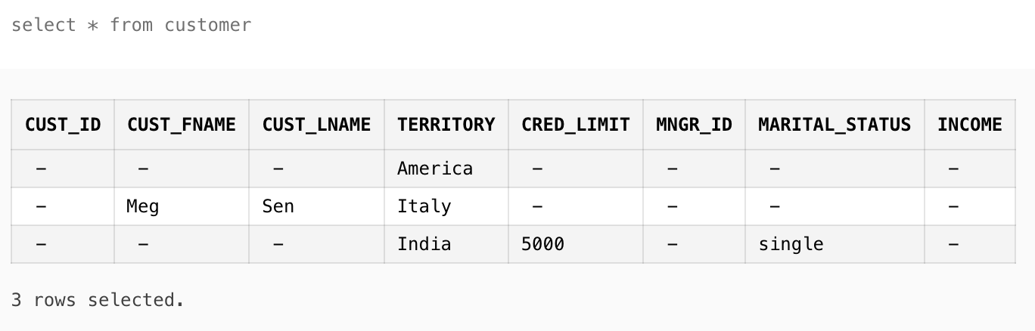

2. Alter table and Add column stay_from_year.

**Query**:

ALTER TABLE customer ADD stay_from_year varchar2(10)

**Output:**

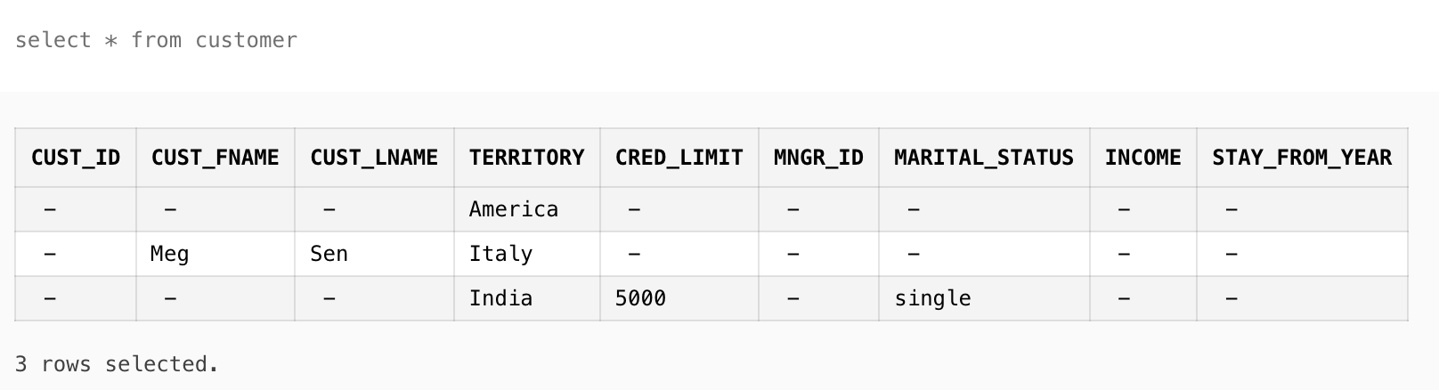

3. Set value of stay_from_year as 2001 for America

**Query:**

UPDATE customer SET stay_from_year='2001' where territory='America'

**Output:**

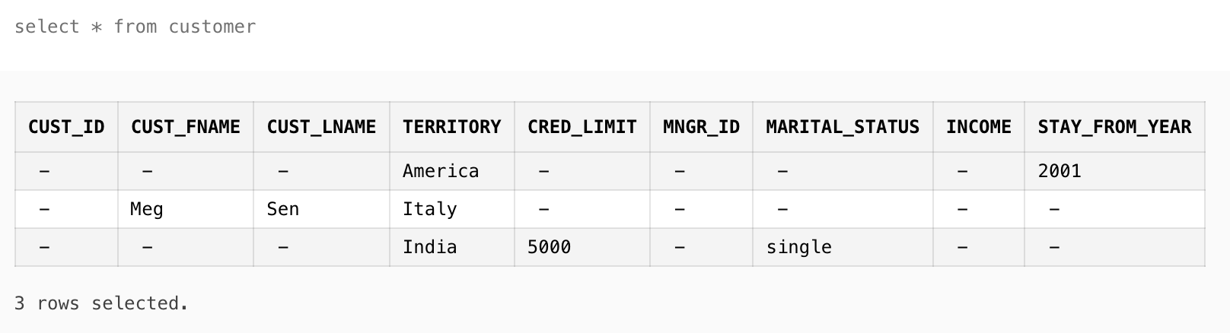

4. Display credit limit attribute for America

**Query:**

select cred_limit from customer where territory='America'

**Output:**

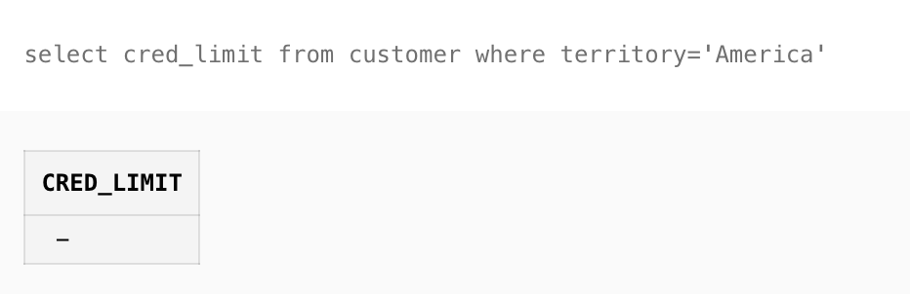

6. Show all data in the territory Italy

**Query:**

select * from customer where territory='Italy'

**Output:**

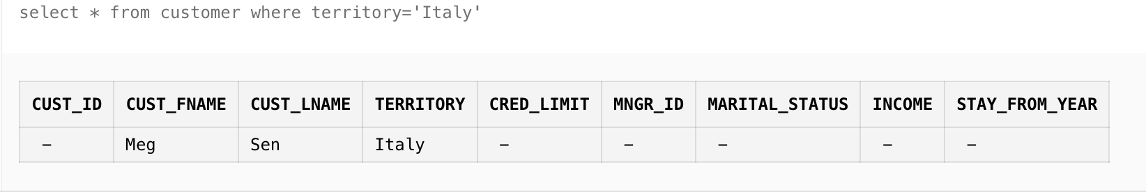

7. If territory is India and status is Single set value of credit to 7000.

**Query:**

update customer set cred_limit=7000 where territory='India' and marital_status='single'

**Output:**

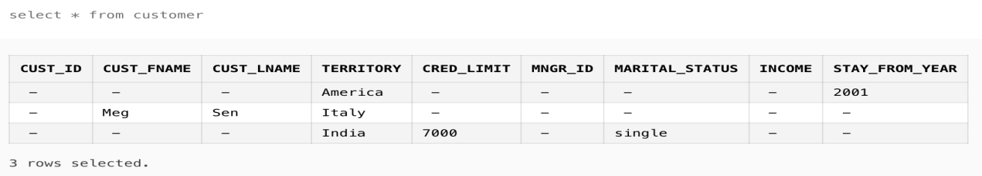

8. Rename cust_fname to first_name

**Query:**

ALTER TABLE customer RENAME COLUMN cust_fname TO first_name

**Output:**

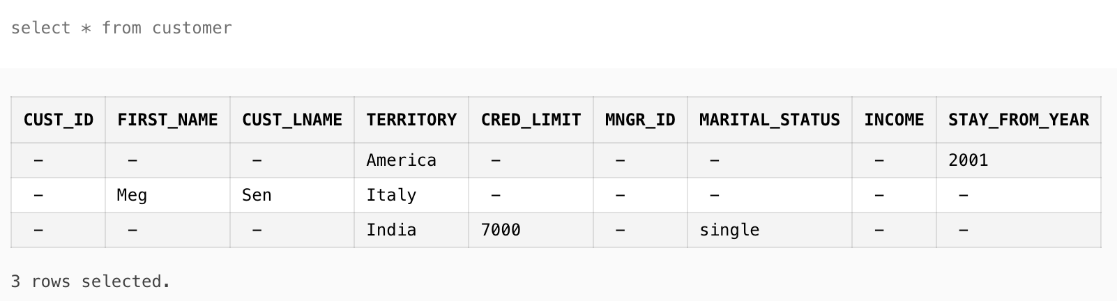

9. Rename cust_lname to last_name

**Query:**

ALTER TABLE customer RENAME COLUMN cust_lname TO last_name

**Output:**

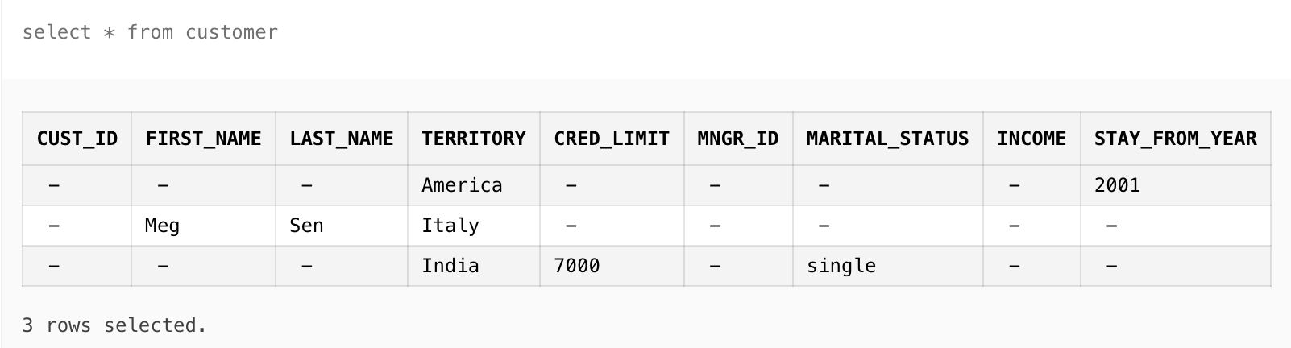

10. Drop column income from customer.

**Query:**

ALTER TABLE customer DROP COLUMN income

**Output:**

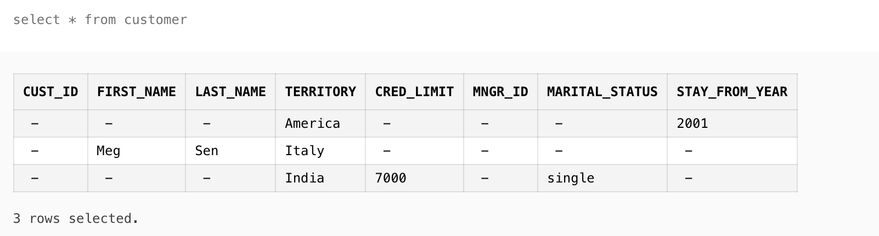

11. Rename table customer to cust_one

**Query:**

RENAME customers To cust_one

**Output:**

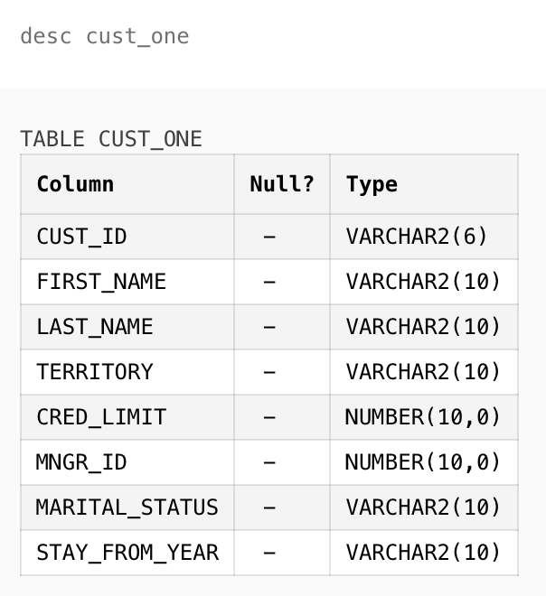

12. alter the table **customer** change cust id to varchar2(6) .

**Query:**

ALTER TABLE cust_one MODIFY cust_id varchar2(6)

**Output:**



13. Add new attribute mngr_name to **customer** and insert 2 records

**Query:**

ALTER TABLE cust_one ADD mngr_name varchar2(10);

insert into

cust_one(cust_id,first_name,last_name,territory,cred_limit,mngr_id,marital_status,stay_from_year,mngr_name) values ('','','','','','','','','suvodeep');

insert into cust_one(cust_id,first_name,last_name,territory,cred_limit,mngr_id,marital_status,stay_from_year,mngr_name) values ('','','','','','','','','amlan');

select * from cust_one

**Output:**

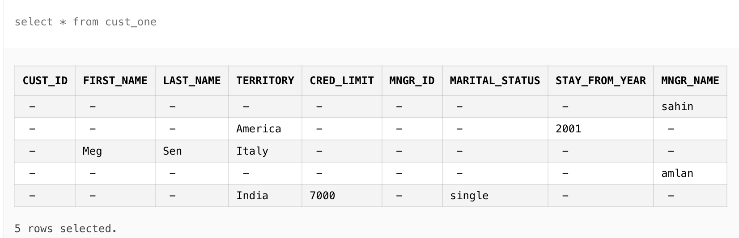

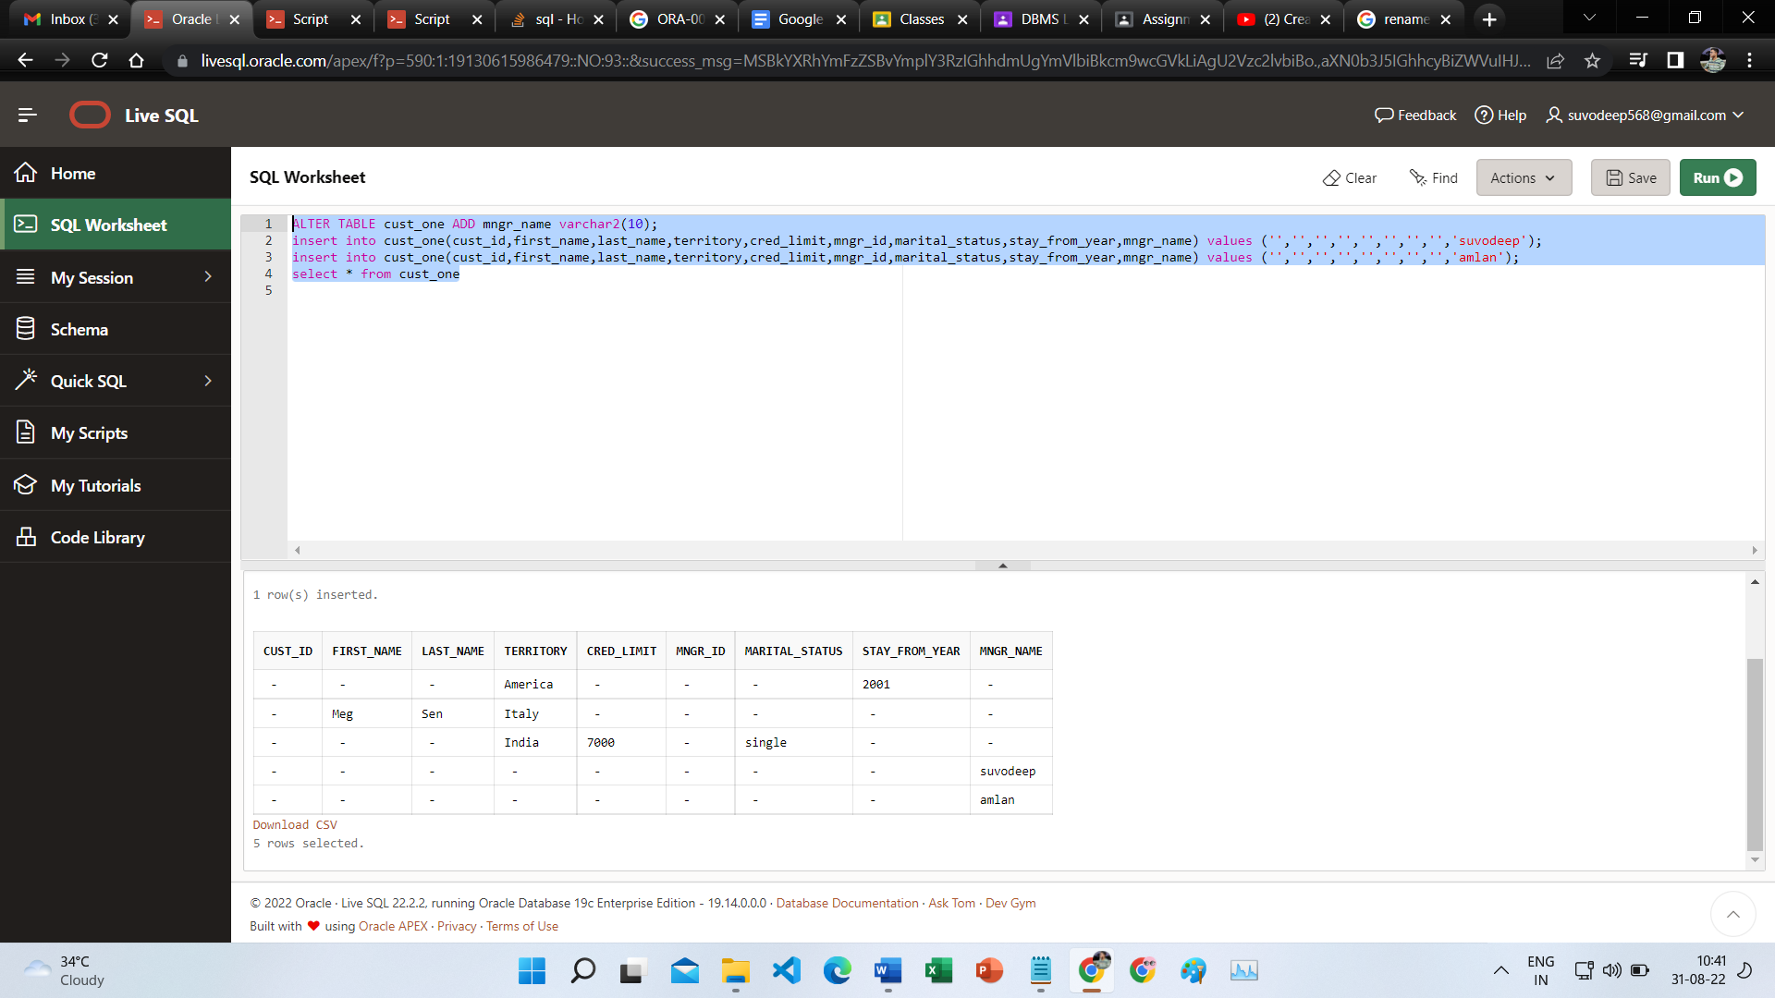

14. Add attribute age to **customer**

**Query:**

alter table cust_one add age number(3)

**Output:**

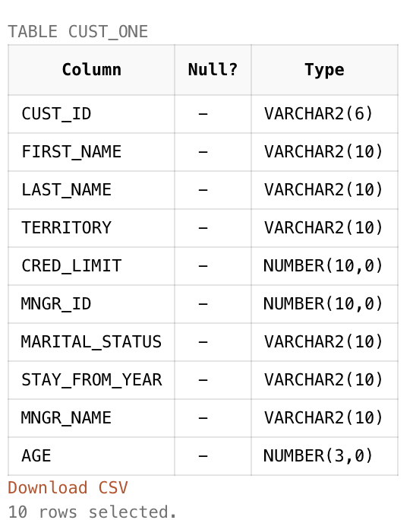

15. Drop table customer and then bring it back.

**Query:**

drop table cust_one

flashback table cust_one to before drop

**Output:**



5. Delete the record corresponding to Meg Sen

**Query:**

DELETE FROM cust_one WHERE first_name='Meg' and last_name='Sen'

Output:

